
ITEM C: Westminster Elementary

PLANNING AND ZONING COMMISION
January 22, 2026

TITLE: Site Development Plan, Westminster Elementary School Addition

REQUEST: Site Development Plan S-24-0032
The Applicant is requesting Site Development Plan Approval to construct two additions for a Pre-Kindergarten and an Instrumental Music classroom addition onto the existing elementary school totaling 3,333 square feet at 811 Uniontown Road, Westminster Maryland 21158.

PROJECT INFORMATION:
LOCATION: 811 Uniontown Road, Westminster Maryland 21158
ZONE: C Conservation Zone

APPLICANT/REPRESENTATIVES:
APPLICANT: Board of Education of Carroll County
OWNER: Board of Education of Carroll County, 125 N Court Street, Westminster, MD 21157
ENGINEER: Mosley Architects, 1414 Key Highway, Second Floor, Baltimore, MD 21230

STAFF: Andrea Gerhard, Senior Planner
Mark A. Depo, Director of Community Planning and Development

RECOMMENDATION: Conditional Approval

ATTACHMENTS:
- Site Development Plan for S-24-0032 Westminster Elementary School Addition
- Construction Brochure provided by Board of Education of Carroll County

STAFF REPORT

Article XXV, Site Plans, of the City of Westminster Zoning Ordinance (“Zoning Ordinance) requires the Planning and Zoning Commission (“Commission”) and Planning Director to review and act on Site Development Plans, and amendments thereto, to ensure that proposed development is in conformity with the intent and provisions of the land use controls and the Comprehensive Plan for the City of Westminster and to avoid inequities and to guide the City in the issuance of building permits. The Commission shall approve, approve subject to conditions, or disapprove the Site Development Plan and amendments thereto.

VICINITY MAP/ LOCATION:

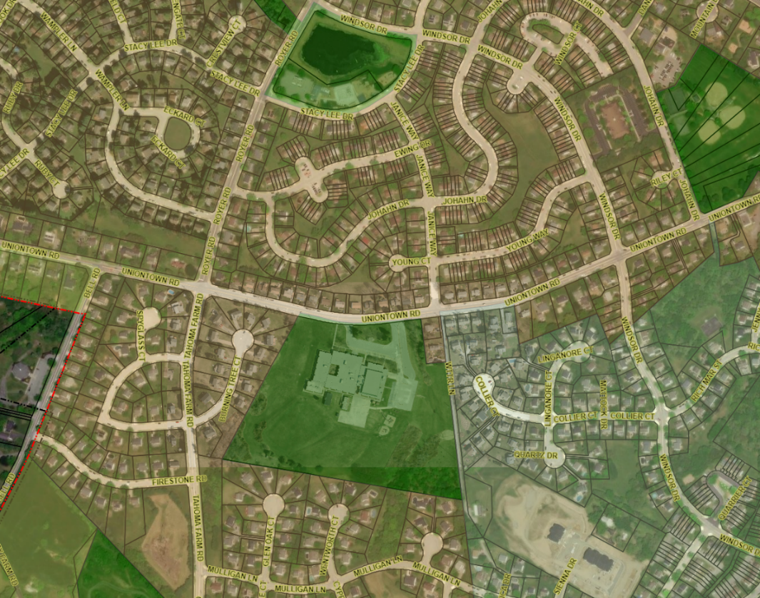
= Property

The subject property is located at 811 Uniontown Road, Westminster Maryland, further identified as SDAT# 07-003544 (the “Property”), hereinafter referred to as the “Property”. The Property is 19.59 acres in area and is zoned C Conservation Zone (Zoning Ordinance Article III), and subject to the Zoning Ordinance.

DEVELOPMENT INFORMATION:

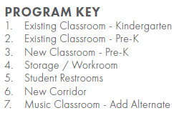
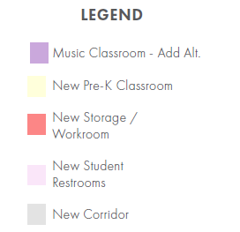
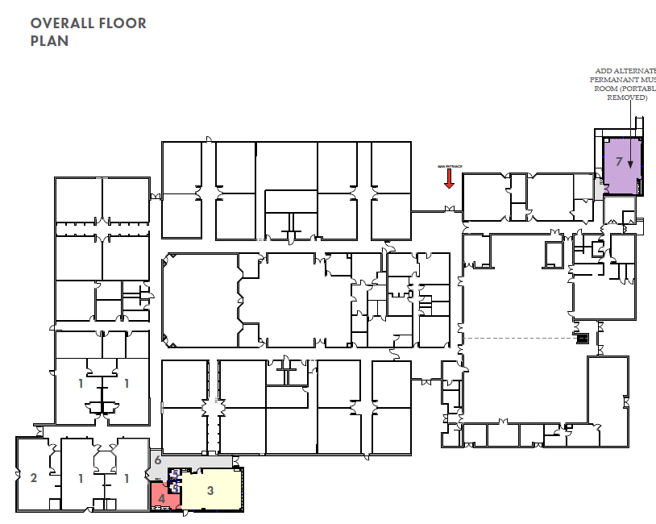
The Board of Education of Carroll County (the “Applicant”), represented by Mosley Architects, filed Site Development Plan S-24-0032, Site Plan for Westminster Elementary School Pre-Kindergarten Addition site plan which was first submitted on January 23, 2025. The revised plans were resubmitted to the City on June 23, 2025. [Attachment 1] S-24-0032 proposes to construct two additions, one for a Pre-Kindergarten and another for an Instrumental Music classroom addition totaling 3,333 square feet. The applicant has also submitted supplemental information through a construction brochure that will better explain the project further [Attachment 2]
Pursuant to Zoning Ordinance Article III, Section 164-12 G., “Schools and colleges, subject to approval of a site development plan by the Commission” is a permitted use in the C Conservation Zone. The purpose of this project is for a Pre-Kindergarten addition to the school to add capacity for more students to satisfy state’s new Blueprint requirements.

SITE DEVELOPMENT PLAN REVIEW COMMENTS:

Landscape Review

Pursuant to Zoning Ordinance Section 164-131.1., Compliance with Landscape Manual, S-24-0032 must comply with the adopted Landscape Manual, as amended. Department of Community Planning and Development (DCPD) staff reviewed S-24-0032 for compliance with the Landscape Manual and other applicable Zoning Ordinance landscape requirements.

No additional landscaping is required for these additions.

Development Design Preferences Manual

Pursuant to Zoning Ordinance Section 164-131.2., Compliance with Development Design Preferences Manual, S-24-0032 must comply with the adopted Development Design Preferences Manual, as amended, in coordination with other provisions and requirements of the Zoning Ordinance. The addition is compatible with the existing building on site.

Elevations for the Pre-School Addition

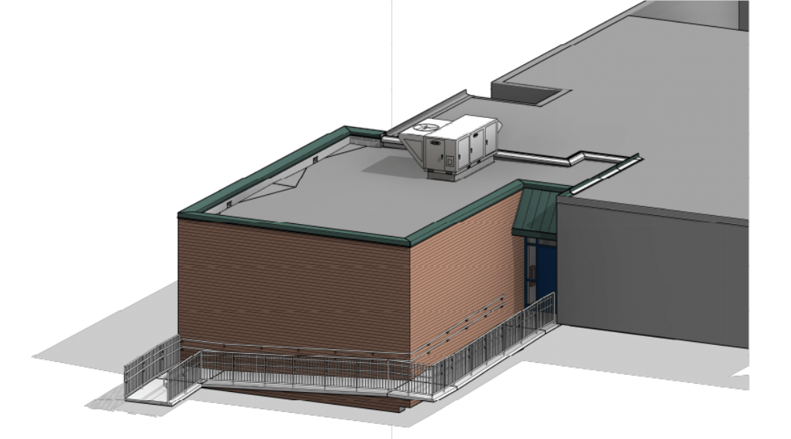

Elevations for the Music School Addition

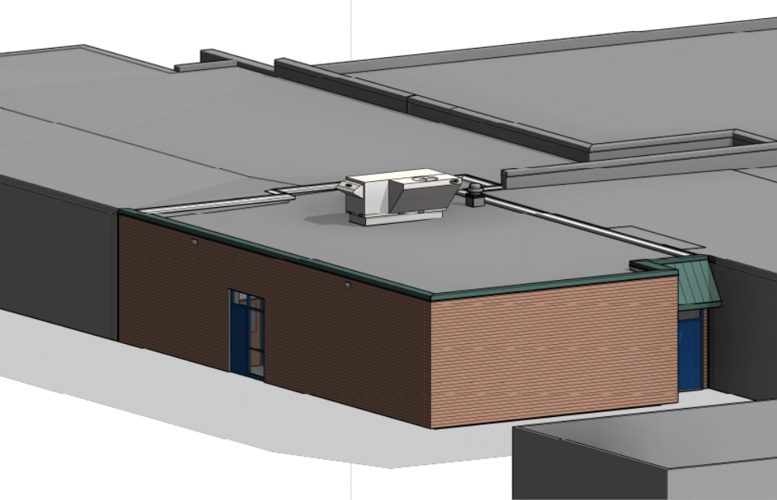

Parking

S-24-0032 must comply with Zoning Ordinance Article XVI, Off Street Parking and Loading. S-24-0032 does not require any additional parking spaces.

Water

Pursuant to the City of Westminster Water and Sewer Allocation Policy 2023-2025, for allocations related to any site development plan, the necessary tentative allocations will be noted on the site plan; however, allocations are granted at the building permit stage. Upon Site Development Plan approval and with the submission of a Water and Sewer Allocation application, tentative allocations are recognized for an additional six months to allow for the building permit review process. Water allocation for this use is based on Maryland Department of Environment multipliers for schools.

The Applicant submitted a Water and Sewer Allocation Application WSA-24-51 for a 1,948 square foot addition. This was based on preliminary drawings. There is no change in water allocation when the actual square footage of the addition, 1,955 square feet, are used. The multiplier for the water was based on the additional capacity for students created by this addition. It was calculated that 400 gpd would be needed to serve the 20 additional students. A note will need to be added to the front cover referencing the WSA information and the water allocated for the project.

PROCESS:

Pursuant to the City’s review process, the Site Development Plan was provided to the appropriate City and County agencies to determine readiness to present to the Westminster Planning and Zoning Commission. Plans were reviewed for compliance with City and County requirements. Carroll County reviewed the plans for grading, utilities, stormwater management, site traffic, and drainage. The City reviewed this project for compliance with applicable, zoning, landscaping, and items contained in the Development Design Preference Manual. The Planning and Zoning Commission shall approve, approve subject to conditions, or disapprove Site Development Plan S-24-0032.

RECOMMENDATION:

DCPD recommends that the Commission consider Conditional Approval of the proposed Site Development Plan S-24-0032, Westminster Elementary School Additions, with the following conditions of approval:

- Address all outstanding City and County comments prior to submission of signature set mylars. This includes but is not limited to adding the City notes, signature blocks and elevations.

DRAFT MOTIONS FOR SITE DEVELOPMENT PLAN S-24-0032

- I move that the Planning and Zoning Commission conditionally approve Site Development Plan S-24-0032, pursuant to City of Westminster Zoning Ordinance Article XXV and based on the January 22, 2026, S-24-0032 Staff Report and conditions of approval.

OR

- I move that the Planning and Zoning Commission deny Site Development Plan S-20-0032.

OR

- I move an alternate motion.

